THE BETHANY PRE AND PRIMARY SCHOOL
CLASS SEVEN TERMINAL REPORT AUGUST 2020
CLASS TEACHER: MATHIAS THOMAS SAMSON

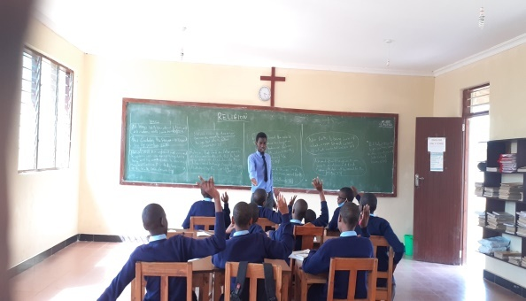
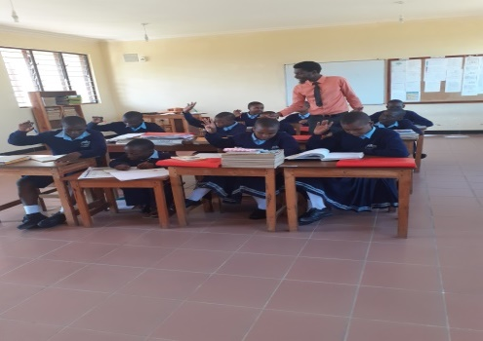

It is with great pleasure that I present class seven terminal report for August 2020 to you Mrs Zephaniah. The report shows how we are progressing as a class, what we have achieved, how well we are going and what we need to focus on the next term.
The attendance of class seven pupils is good whereby four pupils attended all the days of the term, these pupils are Judith Gerald Mungusa, Esther Michael Jackson, Evelyn Lucas Manota and Victoria Joseph Misango. Seven pupils missed some days of the term because of health problems. In the main, the attendance of class seven pupils this term was about 96.6%.

Behaviour
All pupils of class seven are behaving well among themselves and to other people surrounding them, this is proved in different aspects like the act of; following the school rules, behaving well before teachers, parents and their fellow pupils and listening to the advises given to them by teachers about academic, spiritual and social achievements. This good behaviour is the result of continuous counselling given to them by the class teacher on the importance of behaving well in the society. More to the point, the sessions of Religion in my class are helping my pupils to be obedient all the time, I always teach them on how to be submissive, obedient and tolerant as Jesus Christ was behaving when he was in this World.

Quality of teaching and learning
The academic performance of class seven pupils is changing positively. This is evidently shown in both external and internal exams. For instance, the number of pupils who scored A and B average have increased from 4 and 6 respectively in Ward mock examination to 6 and 5 respectively in regional mock examinations. However the class average is increasing in every exam as shown in the graph below:

That is not enough, also even the internal examination results are good, for instance, the average of the weekly exam of 5thJune 2020 and29th June 2020 was 35.6 and 34.1 respectively. Furthermore, the terminal result was 35.9average. All these positive changes were due to the efforts of both teachers and pupils in learning through doing revisions, frequent questioning and corrections as well.
On the other hand, Esther Michael and Judith Gerald have shown positive changes in academic, for instance, they have changed from the average of 32.6 and 29.2 respectively in the ward mock exams to 35 average which is grade B in the regional mock exams. This is the outcome of the frequent academic encouragement given by the class teacher to them.

Judith & Esther

Despite of having positive changes in class seven this term, my pupils are still having the problem of poor spellings. Sometimes they are failing some questions because of misspelling the answers.
School action plans
The school action plans are well considered in class seven, For instance, Teachers are aware of the abilities of class seven pupils and they are helping all pupils accordingly. In addition, all groups of pupils (fast learners and slow learners) are sufficiently challenged through different questions. On the other hand, marking and feedback of pupils work is active in class seven, this has accelerated pupils to get better academically since they are getting corrections of their works. Also all pupils are highly encouraged to demonstrate their knowledge through finding solutions of different problems, this is helping them to be creative and innovative in different areas.
Suggestions
All teachers who are teaching in class seven are required to cooperate with pupils in making follow-up of the syllabus of their subject so as to identify the areas where pupils need to be helped before the national exams. The help can be in form of questions and more clarifications in the concepts where pupils didn’t understand well. In addition, more exams are highly needed to the pupils of class seven, this will make them competent enough to sit for their national exams which will be held on 7th and 8th of October 2020.
In the main, the class seven pupils are better in all spheres together with academic. But we need to keep on praying for them so as they can be healthy enough within the remaining days to their national exams. I hope God is with us and they will stand out in their last exams.
Class seven pupils and I are so grateful to the Bethany supporters for the support courage and heart of helping everyone at the Bethany society to be excellent in all aspects of life like spiritually, socially and academically. We wish you good luck and May our heavenly God bless your earthly life in abundance.

Yours in Christ,
Mathias Thomas Samson
Class teacher

