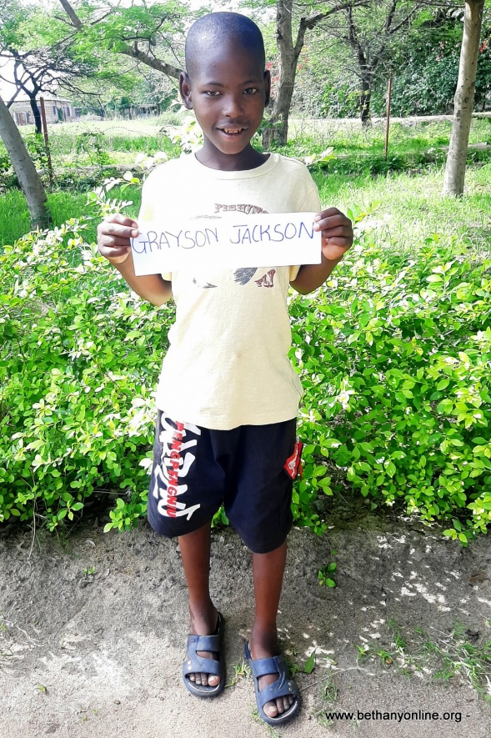
CHILD ADMISSION REPORT AT BETHANY

Full name: Grayson Jackson Paul
Father’s name: Jackson Paul
Mother’s name: Winifrida Korongo
Date of Birth: 25/12/2013
Date of Admission: 01/11/2020
Reason for admission: orphan
Favourite colour: Red
Tribe: Sukuma
Religion: Christian

Class: Toddlers

Favourite subject: Reading
Ambition:
Favourite food: Ugali and Dagaa
Favourite drink: fanta orange
Best friend at Bethany: Joshua Kumalija
Sex: Male
Height: 130 cm
Weight: 27kg

GRAYSON JACKSON PAUL STORY (THIS IS A NAME GIVEN TO HIM AT BETHANY)
Grayson is a boy who was found by a good Samaritan beaten up and thrown in the bushes left to die. He was taken to the police station in Busega District. The police did their best to find the whereabouts of Grayson’s relatives or anyone who would know him. They even put a missing person report on the internet in the vicinity of the Simiyu Region, but no one came forward.
The police handed Grayson to the District’s social welfare and he was admitted at the children’s ward at Busega District hospital for treatment and basic care. After he got better, he continued to stay at the hospital and the nurses on shift had the job of looking after him. Because of the situation he was found in, Grayson displayed some levels of mental disability, however, looking back now, we believe, it must have been the harsh environment that he has been living in that made him become psychologically disturbed.
The social welfare tried to find a place for him for about a month before giving Bethany a call. Early October, Miss Jesca Paulo (Bethany Director) received a phone call from the social welfare asking if Bethany was able to accommodate this child. The social welfare briefly explained about the circumstances but Miss Paulo was not fully convinced so ignored the phone call and asked them to look elsewhere.
Later in October, Mwita (Assistant Director) and Miss Paulo visited the hospital to take some children for some injections and one of the Doctors after seeing the Bethany car approached them and explained about the child. They decided to go and assess the situation and were convinced that Grayson should be admitted to Bethany. So, the social welfare did their report and attached one from the police and handed Grayson to Bethany on the 1st November.
He speaks only Kisukuma tribe (with a very strong accent) which tells us that he comes from very rural areas in Bariadi which is far from where he was found by the Samaritan, he doesn’t remember anything about his home or anyone related to him. However, we thank God he has settled well into Bethany and is slowly learning different things from the others, especially the English language, the Christian values of loving one another and being helpful around here at home and being able to communicate effectively with his fellow children and staff.
He seems to be a child who was not used to a routine or structured lifestyle, eating from rubbish dumps etc, so when he arrived at Bethany, he found it difficult to understand that we had specific times for food, so he would ask for food whenever he saw anyone eating and was very impatient even during morning and evening prayers, Sunday services or school assemblies.
However, after a week at Bethany, he has learnt a great deal and he now follows proper routine and instructions given by staff both at home and school which is a great blessing.
He is a very funny boy, he enjoys singing and dancing.

