BRIEF HISTORY OF A CHILD’S ADMISSION AT BETHANY FAMILY.
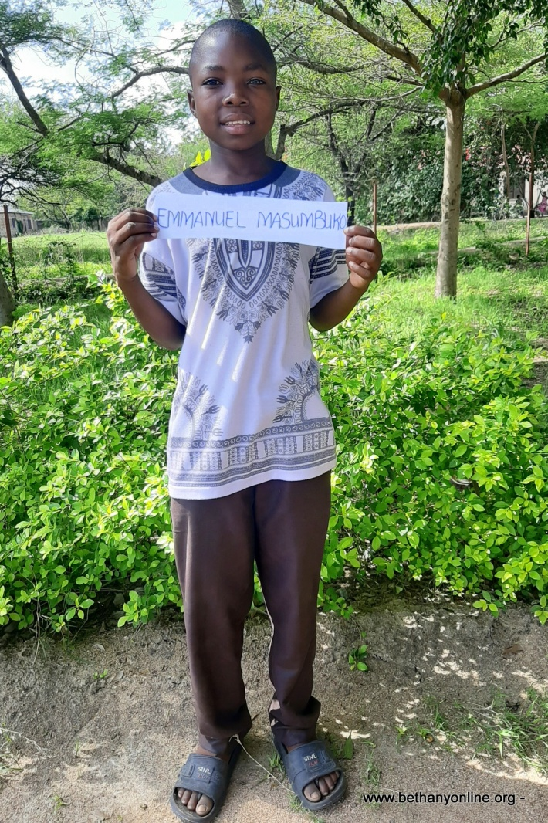
Full name: Emmanuel Masumbuko James
Fathers Name: Masumbuko James
Mother’s Name: Victoria Masaka
Date of Birth: 25/12/ 2007
Place of Birth: Mwasamba
Date of admission: 01/07/2020
Reason of Admission: Orphan
Standard: Reception (to improve his English))
Favourite Subjects: English and Mathematics
Ambition: Soldier
Tribe: Kisukuma
Best food: Rice and Fish
Favourite drink: Soda
Favourite colour: Blue
Best friend at Bethany: Jacobo Charles & Charles Jiganza
Sex: Male
Religion: Christian
Height: 140
Weight: 33

Family history.
Emmanuel was born out of wedlock and lived with his mother who had five other children with different fathers. Emmanuel’s parents never officially got married but his biological father was a subsistence farmer and tried his best to support Emmanuel’s mother to look after the children. Emmanuel started going to school in 2015 but stopped in 2017 when his mother couldn’t cope with looking after her children.
For three years Emmanuel never went to school and was made to stay at home helping his mother with her small business of selling fish and looking after other people’s livestock so that they can get money for food. In 2019 Emmanuel’s family was in so much suffering that the village leaders were involved and the social welfares took actions to help the mother in providing for the children. Emmanuel’s father died with HIV early in 2020, so Emma and his mother did not have even the little help that they received from him. When, they attended his funeral, Emmanuel’s mother decided to leave him with his paternal grandfather who is also unable to look after him. The grandfather decided to ask for help at Bethany.
Emmanuel was admitted at Bethany and he is such a good boy with great attitude. Even though Emmanuel is older than most of his peers but he physically looks just their age and doesn’t feel intimidated being in reception class and having to learn the English language. Emmanuel is quite shy and often very quiet but he interacts well with others and helps the little ones in different things. He has settled very well in Bethany and we hope and pray for a great future ahead for him after all that he has been through. None of Emmanuel’s relatives has ever been to Bethany to visit which is in a way good because it gives him a chance to settle and put the past behind him so that he can focus on his studies.

