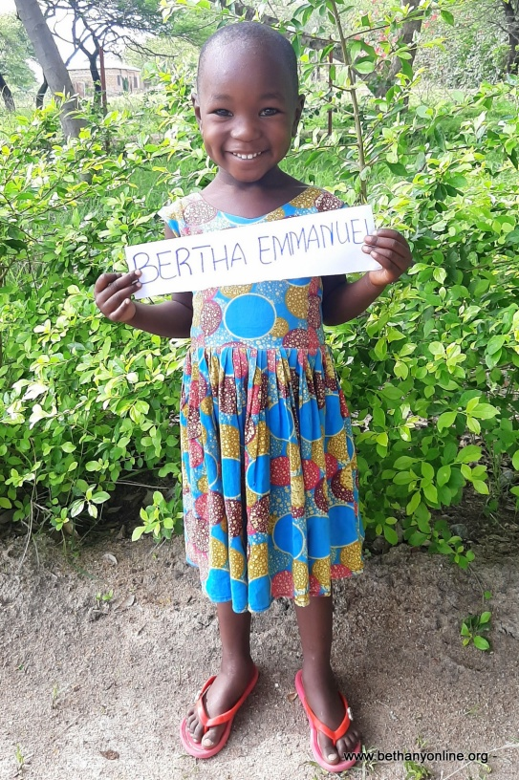
BRIEF HISTORY OF A CHILD’S ADMISSION AT BETHANY FAMILY.
Full name: Bertha Juma Peter
Fathers Name: Juma Peter
Mother’s name: Lucy Joseph
Date of Birth: 03/11/2016
Place of Birth: Sumve
Date of admission: 16/11/2020
Reason of Admission: Abandoned
Best colour: Red
Favourite food: Makande
Best friend: Diana Joseph
Best subject: Writing
Tribe: Sukuma
Class: Toddlers
Sex: Female
Religion: Christian
Height: 94cm
Weight: 10kg
BERTHA’S HISTORY:
Bertha has two sisters at Bethany (a set of twins, Eunice and Yulitha) and two older brothers (not at Bethany). All five children stayed with their mother without their father. Their father abandoned the mother when she was pregnant with Bertha. Their mother was jobless and couldn’t take care of her children. She is a subsistence farmer who gets by with what she can grow when there’s enough rain. Bertha’s mother decided to abandon her children with her mother (Bertha’s grandmother). The grandmother was very poor and she couldn’t look after the children. One of the two older boys ran away when things got hard and went into the streets to beg. So Bertha’s grandmother sought for help from the village leader who directed her to the District’s social welfare who rang Bethany for help. Since the young children including Bertha and her twin sisters seemed to be most affected, Bethany decided to take all of them and admit them. All three children have settled in at Bethany and even though they are a little shy and don’t mix very much with others, but slowly they are getting into the routine.

